Software Testing Assignment Rupali Barchha

**Module 1 (Fundamental)**

1. **What is SDLC?**

SDLC (System Development Life Cycle) is a structure imposed on the development of a software product that defines the process for planning, implementation, testing, documentation, deployment, and ongoing maintenance and support.

1. **What is software testing?**

Software Testing is a process used to identify the correctness, completeness, and quality of developed computer software.

1. **What is agile methodology?**

The Agile methodology is a project management approach that involves breaking the project into phases and emphasizes continuous collaboration and improvement.

1. **What is SRS?**

A software requirements specification (SRS) is a complete description of the behavior of the system to be development.

1. **What is oops?**

Object- oriented programming system is a computer programming model that organizes software design around data, or objects, rather than functions and logic.

1. **Write Basic Concept of oops.**

Basic concept of oops are:

1) Object 2) Class 3) Encapsulation 4) Inheritance 5) Polymorphism 6) Abstraction

1. **What is Object?**

Any Tangible things, roles, incidents, interactions, specifications is object.

An object represents an individual, identifiable item, unit or entity, either real or abstract, with a well-defined role in the problem domain.

An object is anything to which concept applies. Object = Data +Methods

Object is a particular instance of class.

1. **What is Class?**

Class is a blueprint for an object which describes the properties and behavior of that object, but without any actual existence.

1. **What is encapsulation?**

Encapsulation in OOPs is the process of wrapping up of data (properties) and method (behavior) together as a single unit. The unit here is a class (or interface).

Encapsulation enables data hiding, hiding irrelevant information from the users of a class and exposing only the relevant details required by the user.

1. **What is inheritance?**

Inheritance means that one class inherits the characteristics of another class. This is also called a “is a” relationship. One of the most useful aspect of object oriented programming is code reusability.

As the name suggest Inheritance is the process of forming a new class from an existing class that is from the existing class called as base class, new class is formed called as derived class.

1. **What is polymorphism?**

Polymorphism means “having many forms”. It allows different objects to respond to the same message in different ways, the response specific to the type of object.

Poly refers too many. That is a single function or an operator functioning in many ways different upon the usage is called polymorphism.

There is two types of polymorphism: Method Overloading (Compile time) and Method Overriding (Run time)

1. **Draw use case on online book shopping.**

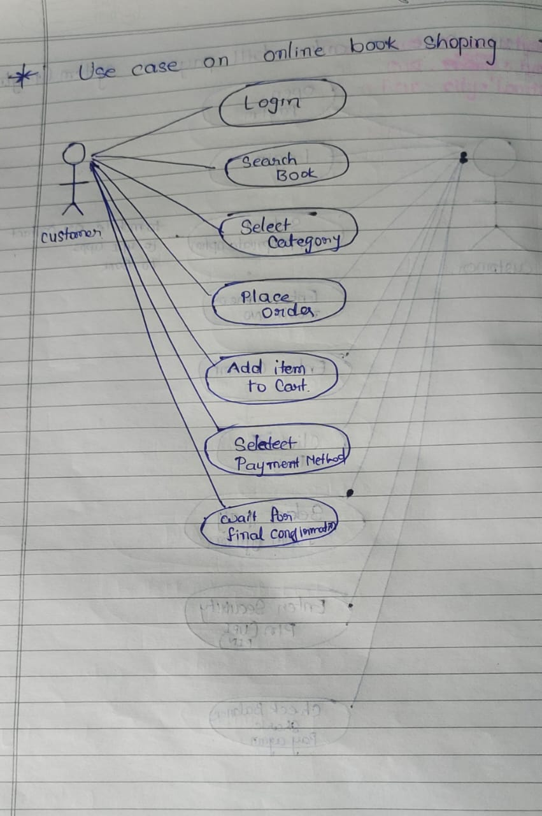

1. **Draw use case on online bill payment system(paytm)**

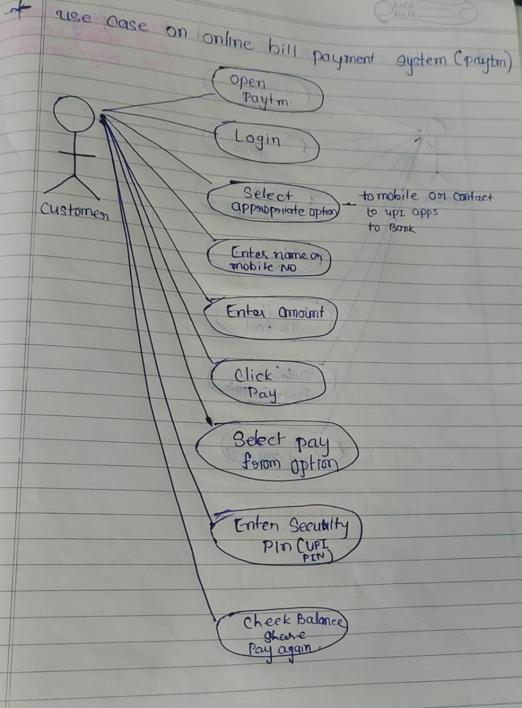

1. **Write SDLC phases with basic introduction.**

Following are the SDLC phases:

* Requirements collection / Gathering :

It involves understanding the client’s needs and identifying their problem.

Types of Requirements: Functional Requirements, Non-Functional requirements

Three types of problem can arise: 1) Lack of clarity 2) Requirement confusion 3) Requirements Amalgamation.

* Analysis

It defines the requirements of the system, independent of how these requirements will be accomplished.

* Design

It involves transforming the software requirements gathered during the requirements Analysis phase into a structured design document.

* Implementation

It puts the project into action.

* Testing

It includes checking all the components, functions, features, and every tiny things in the software system.

* Maintenance

Maintenance is the process of changing a system after it has been deployed.

1. **Explain Phases of the waterfall model**

The waterfall model has following phases:

1. Requirement Gathering and Analysis: It involves gathering requirements from stakeholder and analyzing them to understand the scope and objectives of the project.
2. Design Phase: It involves creating a detailed design document that outlines the software architecture, user interface, and system components.
3. Implementation and Unit Testing: It involves coding the software based on the design specifications. This phase also includes unit testing to ensure that each components of the software is working as expected.
4. System Testing: In the testing phase, the software is tested as a whole to ensure that it meets the requirements and is free from defects.
5. Deployment: Once the software has been tested and approved, it is deployed to the production environment.
6. Maintenance: The final phase of waterfall model is maintence, which involves fixing any issues that arise the software has been deployed and ensuring that it continues to meet the requirements.
7. **Write phases of spiral model.**
8. Planning: It is the first phase of spiral model, where the scope of the project is determined and a plan is created for the next iteration of the spiral.
9. Risk Analysis: In this phase the risks associated with the project are identified and evaluated.
10. Engineering: In this phase, the software is developed based on the requirements gathered in the previous iteration.
11. Evaluation: In this phase, the software is evaluated to determine if it meets the customer’s requirements and if it is of high quality.
12. Planning: The next iteration of the spiral begins with a new planning phase, based on the results of the evaluation.
13. **Write agile manifesto principles.**

Agile model believe that every project needs to be handle differently and the existing methods need to be tailored to best suit the project requirements.

In agile the tasks are divided to time boxes to deliver specific features for a release.

1. **Explain working methodology of agile model and also write pros and cons.**

* Agile model is a combination of iterative and incremental process models with focus on process adaptability and customer satisfaction by rapid delivery of working software product.
* Agile methods break the product into small incremental builds. These builds are provided in iterations. Each iteration typically lasts from about one to three weeks.
* Every iteration involves cross functional teams working simultaneously on various areas like planning, requirements analysis, design, coding, unit testing and acceptance testing.
* At the end of the iteration a working product is displayed to the customer and important stakeholders.

**Pros:**

* Good model for environments that change steadily.
* Resource requirements are minimum.
* Little or no planning required
* Easy to manage
* Gives flexibility to developers
* Suitable for fixed or changing requirements.
* Delivers early partial working solutions.
* Functionality can be developed rapidly and demonstrated.

**Cons:**

* Not suitable for handling complex dependencies.
* More risk of sustainability, maintainability and extensibility.
* Depends heavily on customer interaction.so if customer is not clear, team can be driven in wrong direction.
* Transfer of technology to new team members may be quite challenging due to lack of documentation use-case

1. **Draw use case on online shopping product using COD.**

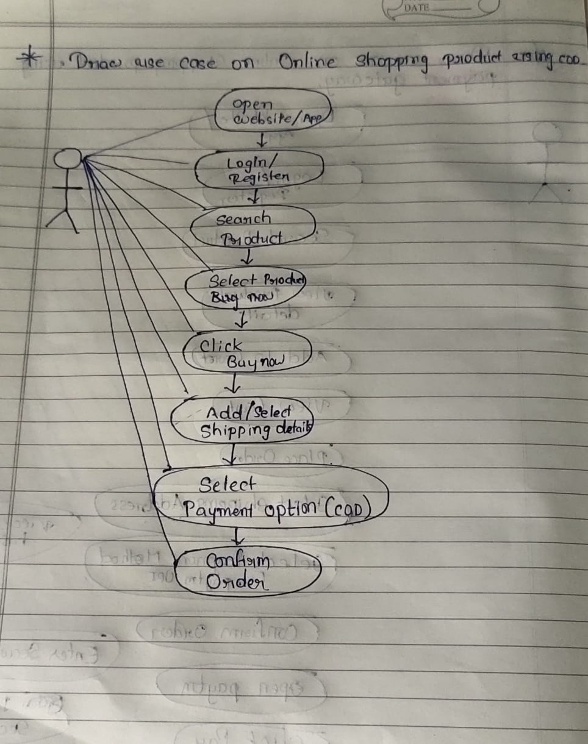

1. **Draw use case on online shopping product using payment gateway.**

